Dharmsinh Desai University



Academic Year : 2022-23

Department of Management & Information Science

Subject : Car Website

Full Name : Rana Shivam Vijaykumar

Roll No: MA049

ID No : 22MAPBG004

Submitted To: Prof. Minal V Shah

MCA

Department

Student Sign Authority Sign

**Description Of Project**

* **Problem Statement :**

To Creating Website for car company which shows the description and specification of the car. It should also provide the detail image gallery for the car that interested person wanted to know and watch. In addition It should provide the facility to book the test drive for the available model. Or should ask the user are they wanted to detail inquiry of that selected car. Also it should provide a video of the same. The website should able to let the know the user the legacy of that car company and future plans.

* **Structure Of Website:**
  + **Home Page:**
    - Classic : Leads Towards Legacy of the cars and the company
    - Innovation : Leads Towards The Future Technology
    - Vehicles : Leads Towards The Vehicles sold by company for detail
    - Book: Leads toward book the test-drive or inquire about
    - Owners: The customers of the company, provide the maintenance and help to them
    - Logo: Leads To the home page
    - Search Button: Provide Search to find out the cars
    - Location : Locate the dealers of the company
    - Slider : The sliders image leads to the page of the car shown
    - Footer : shows the information of the company
* **Classic:**
  + Let Visitor Know the legacy of the company
  + Contribution in the sports and racing
  + The Legendary Cars of the era
* **Innovation:**
  + Overview of the upcoming car
  + The technological advancement
  + Companies future plans and preparedness for upcoming era
* **Vehicles:** 
  + Leads toward the companies model available to sold
  + Mainly for jaguar in this case XF, F-type and F-Pace are available
  + Each Leads to their Detail Description and image gallery
* **Book:** 
  + Provides the facility to book test-drive or to know more about that car
  + It will ask for some contact information
* **Owners:** 
  + The Owners of the cars (not developed because the requirement of dbms).

**JAGUAR HOME PAGE**

**FILE NAME : car_wesite_tw.html**

<!DOCTYPE html>

<html lang="en">

<head>

    <meta charset="UTF-8">

    <meta http-equiv="X-UA-Compatible" content="IE=edge">

    <meta name="viewport" content="width=device-width, initial-scale=1.0">

    <title>Jaguar</title>

    <link rel="icon" href="./jaguar_pic/icon.jpg" type="x-image/icon">

    <link rel="stylesheet" href="./tw_car_website.css">

    <script src="./jaguar.js" type="text/javascript"></script>

</head>

<body>

    <div id="headnav">

        <div id="head">

        <header>

            <h1 id="emptlogo"></h1>

            <a href="./car_website_tw.html" ><img src="./jaguar_pic/jaglogo.jpg" alt="" width="100px" height="40px" id="logo"></a>

            <h1 class="right1" ></h1>

            <div class="dp">

                <img src="./jaguar_pic/search.jpg" onclick="search()" class="right" id="searchimg">

                <div id="mdp" class="dpc">

                    <input type="text" id="ip" placeholder="search" onkeyup="filter()">

                    <a href="./f-pace.html">F-face</a>

                    <a href="./f-type.html">F-type</a>

                    <a href="./xf.html">xf</a>

                    <a href="./jaguar_future.html">vision gt</a>

                    <a href="./jaguar_culture.html">classic</a>

                    <a href="./test-drive.html">Book</a>

                </div>

            </div>

            <a href="https://www.jaguar.in/retailer-locator/index.html" ><img src="./jaguar_pic/pin.jpg" alt="" class="rightlocate"></a>

        </header>

    </div>

    <!-- navigation bar start-->

    <div id="nav">

    <nav>

        <ul>

            <li><a href="./jaguar_culture.html" class="nbar">Classic</a></li>

            <li><a href="./jaguar_future.html" class="nbar">Innovation</a></li>

            <li><a href="#lx" class="nbar">Vehicles</a></li>

            <li><a href="./test-drive.html" class="nbar">Testdrive</a></li>

            <li><a href="#" class="nbar">Owners</a></li>

        </ul>

    </nav>

    </div>

    </div>

    <!-- navigation bar end -->

    <div class="slider">

        <div class="slides">

            <!-- radio button start -->

            <input type="radio" name="radio_btn" id="rd1">

            <input type="radio" name="radio_btn" id="rd2">

            <input type="radio" name="radio_btn" id="rd3">

            <input type="radio" name="radio_btn" id="rd4">

            <!-- radio button end -->

            <!-- slide image start -->

            <div class="slide f">

                <a href="./f-type.html"><img src="./vehicles/ft12.jpg" alt=""></a>

            </div>

            <div class="slide">

                <a href="./f-pace.html"><img src="./vehicles/f13.jpg" alt=""></a>

            </div>

            <div class="slide">

                <a href="./xf.html"><img src="./vehicles/xf.jpg" alt=""></a>

            </div>

            <div class="slide">

                <img src="./vehicles/jagxj1.jpg" alt="">

            </div>

            <div class="navigation_manual">

                <label for="rd1" class="manual_btn"></label>

                <label for="rd2" class="manual_btn"></label>

                <label for="rd3" class="manual_btn"></label>

                <label for="rd4" class="manual_btn"></label>

            </div>

            <!-- manaual navigation end -->

        </div>

    </div>

    <script type="text/javascript">

        var counter = 1;

        setInterval(

            function(){

                document.getElementById('rd'+counter).checked = true;

                counter++;

                if(counter>4){

                    counter=1;

                }

            },5000

        );

    </script>

    <p id="lx"></p>

    <h1 id="v">VEHICLES</h1>

    <div id="temp">

        <div class="c">

            <h1>F-type</h1>

            <a href="./f-type.html"><img src="./vehicles/f-type.jpg" alt="ftypegt" width="300px" height="180px" class="m_img"></a>

            <p>Jaguar f-type r</p>

            <p>Perfomance Sports Car</p>

        </div>

        <div class="c">

            <h1>Jaguar XF</h1>

            <a href="./xf.html"><img src="./vehicles/xf.jpg" alt="XF" width="300px" height="180px" class="m_img"></a>

            <p>Luxury Sedan</p>

            <p>Ultimate Your Comfort</p>

        </div>

        <div class="c">

            <h1>Jaguar F-Pace</h1>

            <a href="./f-pace.html"><img src="./vehicles/f-face.jpg" alt="XJ" width="300px" height="180px" class="m_img"></a>

            <p>Ultimate Luxury SUV</p>

            <p>Comfort with rougidness</p>

        </div>

    </div>

    <div>

        <footer>

            <h2>© JAGUAR LAND ROVER LIMITED 2022</h2>

            <p>Registered Office: Abbey Road, Whitley, Coventry CV3 4LF

               <br> Registered in England No: 1672070</p>

            <p style="text-align: left; padding:10px 100px;">There is currently a global shortage of semi-conductor components. Jaguar Land Rover India Limited (JLRIL) is affected by this shortage and as a result, certain Jaguar and Land Rover products may not be available and delivery timelines for some products may be extended by authorised Jaguar Land Rover Retailers. Please contact your authorised Jaguar Land Rover Retailer for further updates.</p>

            <p style="text-align: left; padding:10px 100px;">The fuel consumption figures provided are as a result of official manufacturer's tests in accordance with EU legislation. A vehicle's actual fuel consumption may differ from that achieved in such tests and these figures are for comparative purposes only.</p>

            <p style="text-align: left; padding:10px 100px;">Important note on imagery & specification. We are living through exceptional times. Due to the Covid pandemic we have been prevented or delayed in the creation of new images of current model years. Now the global impact of micro-chip shortages is further affecting build specifications, options and launch timings. Until this unique event settles, please note that many images cannot be updated to 23 model year specifications. Features, options, trim and colour schemes will differ from many images. Customers are urged to consult your local Retailer for detailed 23 model year specifications and do not base an order on marketing imagery and specification alone.</p>

           <p style="text-align: left; padding:10px 100px;">The information, specification, engines and colours on this website are based on European specification and may vary from market to market and are subject to change without notice. Some vehicles are shown with optional equipment and retailer-fit accessories that may not be available in all markets. Please contact your local retailer for local availability and prices.s</p>

        </footer>

    </div>

</body>

</html>

**JAGUAR MAIN CSS FILE**

**File name:** tw_car_website.css

**FILES ATTACHED WITH**

* Car_wbsite_tw.html
* f-pace.html
* f-type.html
* jaguar_culture.html
* jaguar_future.html
* test-drive.html
* xf.html

body{

    margin: 0;

    padding:0;

    justify-content: center;

    text-align: center;

    overflow-x: hidden;

}

#headnav {

    position: fixed;

    top: 0;

    width: 100%;

    background-color: #000000b6;

    z-index: 10;

}

nav{

    margin-top: 5.25%;

    display: flex;

    position: relative;

    flex-direction: row;

    flex-wrap: wrap;

    width: 100%;

    text-align: center;

    justify-content: center;

    background-color: #000000b6;

}

nav ul{

    display: flex;

    justify-content:center;

    text-align: center;

}

nav ul li{

    margin-right: 7%;

    margin-left: 7%;

    list-style: none;

    color: #d9fdf8;

    margin-top: 10px;

}

nav ul li a{

    text-decoration: none;

    color: #d9fdf8a7;

}

.nbar:hover{

    color:#e2fffb;

    transition: 1s;

}

/* second header style secotion */

header{

    display: flex;

    float: left;

    top: 0%;

    width: 100%;

    background-color: #191414;

    padding: 1%;

}

/* for search */

#searchimg{

    cursor: pointer;

}

#ip{

    box-sizing: border-box;

    font-size: 15px;

    padding: 10px;

    border: none;

    border-bottom: 1px solid #ddd;

}

#ip:focus{outline: 3px solid #ddd;}

.dp{

    position: relative;

    display: inline-block;

}

.dpc{

    display: none;

    position: absolute;

    min-width: 50px;

    border: 1px solid #ddd;

    background-color: #000000b6;

    z-index: 1;

}

.dpc a{

    color: white;

    font-size: 12px;

    padding: 5% 2%;

    text-decoration: none;

    display: block;

}

.dpc a:hover{opacity: .7; transition: 1s;}

.show{display: block;}

/* search end */

#emptlogo{

    margin-left: 45vw;

}

#logo{

    opacity: .8;

}

#logo:hover{

    opacity: 1;

    transition: 1s;

}

.right1{

    margin-top: 1%;

    margin-left: 26vw;

    padding-right: 3vw;

    opacity: .7;

}

.right{

    margin-left: 6vw;

    margin-top: 8px;

    margin-right: 20px;

    opacity: .7;

}

.rightlocate{

    margin-top: 4px;

    opacity: .7;

}

.rightlocate:hover{

    transition: 1s;

    opacity: 1;

}

.right:hover{

    transition: 1s;

    opacity: 1;

}

/* navigation bar end */

.slider{

    width: 100vw;

    height: 100vh;

    overflow: hidden;

}

.slides{

    width: 500%;

    height: 500px;

    display: flex;

}

.slides input{

    display: none;

}

.slide{

    width: 20%;

    transition: 2s;

}

.slide img{

    width:100vw;

    height: 100vh;

}

/* navigation manual  */

.navigation_manual{

    position: absolute;

    width: 100%;

    display: flex;

    justify-content: center;

    bottom: 50px;

    z-index: 0;

}

.manual_btn{

    padding: 5px;

    cursor: pointer;

    transition:1s;

    border-radius: 10px;

    border:2px solid #ade0e0;

    margin-right: 40px;

}

.manual_btn:hover{

    background-color:#ade0e0;

}

#rd1:checked ~ .f{

    margin-left: 0;

}

#rd2:checked ~ .f{

    margin-left: -20%;

}

#rd3:checked ~ .f{

    margin-left: -40%;

}

#rd4:checked ~ .f{

    margin-left: -60%;

}

/* navigation automatic */

.navigation_auto{

    position: absolute;

    width: 1200px;

    display: flex;

    margin-top: 500px;

    justify-content: center;

}

.navigation_auto div{

    padding: 5px;

    border-radius: 10px;

    transition: 1s;

    border:2px solid #ade0e0;

    margin-right: 40px;

}

#rd1:checked ~ .navigation_auto .auto_btn1{

    background-color:#ade0e0;

}

#rd2:checked ~ .navigation_auto .auto_btn2{

    background-color:#ade0e0;

}

#rd3:checked ~ .navigation_auto .auto_btn3{

    background-color:#ade0e0;

}

#rd4:checked ~ .navigation_auto .auto_btn4{

    background-color:#ade0e0;

}

/* slider ends */

#temp{

    display: flex;

    width: 100vw;

    background-color: rgba(185, 183, 183, 0.799);

}

.c{padding: 5%;}

/* for models */

.m_img{

    width:"300px";

    height:"180px";

}

#v{

    background-color: #bd8e8ed6;

    margin: 0;

    padding: 3%;

    width: auto;

}

#lx{

    padding: 0;

    margin: 0%;

}

**JAGUAR Javascript**

**File name:** jaguar.js

//for search

function search(){

    document.getElementById("mdp").classList.toggle("show");

}

function filter(){

    var input, filt, li, a, i, ft;

    input = document.getElementById("ip");

    filt = input.value.toUpperCase();

    ft = document.getElementById("mdp");

    a = ft.getElementsByTagName("a");

    for(i=0; i<a.length; i++){

        txtValue = a[i].textContent || a[i].innerText;

        if(txtValue.toUpperCase().indexOf(filt) > -1){

            a[i].style.display = "";

        }else{

            a[i].style.display = "none";

        }

    }

}

//for test drive aleart file test-drive.html

var fname, lname, date, model, city;

fname = document.getElementById("fname");

lname = document.getElementById("lname");

date = document.getElementById("dt");

model = document.getElementById("mod");

city = document.getElementById("city");

function testdrive(){

    if(fname.value=="" || fname.value==null ||lname.value=="" || lname.value==null || date.value=="" || date.value==null || model.value=="" || model.value==null || city=="" || city==null){

        alert("fill requred feilds");

    }else{

        alert("Thank You! \n" + fname.value + " " + lname.value + " Your Test Drive Booked On " + date.value + " for Jaguar Model " + model.value + " In " + city.value + " City.");}

**JAGUAR INNOVATION**

**File name:** jaguar_future.html

<!DOCTYPE html>

<html lang="en">

<head>

    <meta charset="UTF-8">

    <meta http-equiv="X-UA-Compatible" content="IE=edge">

    <meta name="viewport" content="width=device-width, initial-scale=1.0">

    <title>jaguar Innovation and sports</title>

    <link rel="icon" href="./jaguar_pic/icon.jpg" type="x-image/icon">

    <link rel="stylesheet" href="./tw_car_website.css">

    <link rel="stylesheet" href="./future.css">

    <script src="./jaguar.js" type="text/javascript"></script>

</head>

<body>

    <!-- header part -->

    <div id="headnav">

        <div id="head">

        <header>

            <h1 id="emptlogo"></h1>

            <a href="./car_website_tw.html" ><img src="./jaguar_pic/jaglogo.jpg" alt="" width="100px" height="40px" id="logo"></a>

            <h1 class="right1" ></h1>

            <div class="dp">

  <img src="./jaguar_pic/search.jpg" onclick="search()" class="right" id="searchimg">

                <div id="mdp" class="dpc">

                <input type="text" id="ip" placeholder="search" onkeyup="filter()">

                    <a href="./f-pace.html">F-face</a>

                    <a href="./f-type.html">F-type</a>

                    <a href="./xf.html">xf</a>

                    <a href="./jaguar_future.html">vision gt</a>

                    <a href="./jaguar_culture.html">classic</a>

                    <a href="./test-drive.html">test-drive</a>

                </div>

            </div>

            <a href="https://www.jaguar.in/retailer-locator/index.html" ><img src="./jaguar_pic/pin.jpg" alt="" class="rightlocate"></a>

        </header>

    </div>

        <!-- navigation bar start-->

        <div id="nav">

            <nav>

                <ul>

                    <li><a href="./jaguar_culture.html" class="nbar">Classic</a></li>

                    <!-- <li><a href="#" class="nbar">Innovation</a></li> -->

                    <li><a href="#" class="nbar">Innovation</a></li>

                    <li><a href="./car_website_tw.html #lx" class="nbar">Vehicles</a></li>

                    <li><a href="./test-drive.html" class="nbar">Book</a></li>

                    <li><a href="#" class="nbar">Owners</a></li>

                </ul>

            </nav>

        </div>

    </div>

        <!-- navigation bar end -->

    <div id="vidvision">

    <video src="./vehicles/visiongt/visiongt.mp4" loop autoplay width="100%" height="100%" muted>

            <source src="./vehicles/visiongt/visiongt.mp4">

        </video>

    </div>

    <h1 style="color: #c9ebfc;">JAGUAR VISION</h1>

    <div class="d1">

        <div class="imgdiv">

     <img class="cars rt" src="./vehicles/visiongt/jaguar-vision-gt-sv03.jpg" alt="">

        </div>

        <h2 class="textdiv">High Tech Computerized Cabin</h2>

    </div>

    <div class="d11">

        <div class="imgdiv">

            <img class="cars" src="./vehicles/visiongt/vs3.jpg" alt="">

        </div>

    </div>

    <div class="divinfo">

        <h1>THE ELECTRIFYING NEW CHAPTER IN OUR GRAN TURISMO STORY</h1><br>

        <p>A maximum speed of 410 km/h, an aerodynamic design honed to perfection and podium-topping technology define <br> the Jaguar Vision Gran Turismo SV – our latest all-electric virtual race car developed for Gran Turismo and built as a full-scale <br> design study.</p>

    </div>

    <div class="d1">

        <div class="imgdiv">

    <img class="cars rt" src="./vehicles/visiongt/jaguar-vision-gt-sv01.jpg" alt="" >

        </div>

        <div  class="textdiv">

            <h2>Carved For Stunning Speed</h2>

        </div>

    </div>

    <div class="d11">

        <div class="imgdiv">

            <img class="cars" src="./vehicles/visiongt/jaguar.jpg" alt="">

        </div>

    </div>

    <div id="info" class="divinfo">

        <div>

            <h2>Top Speed</h2>

            <h1>410kmph</h1>

            <p>Numbers that reflect the ultimate electric endurance racer</p>

        </div>

        <div>

            <h2>Engine Power</h2>

            <h1>1400 kw</h1>

            <p>Four electric motors are powered by a state-of-the-art 100kWh lithium-ion battery pack</p>

        </div>

        <div>

            <h2>Accelaration</h2>

            <h1>1.71 sec</h1>

        <p>(0 - 100kmph) A thoroughbred Jaguar sports car from a standing start</p>

        </div>

        <div>

            <h2>Instant Torque</h2>

            <h1>3360 Nm</h1>

            <p>Intelligent all-wheel drive and torque vectoring ensure even greater agility and control</p>

        </div>

    </div>

    <div class="d1">

        <div class="imgdiv">

            <img class="cars" src="./vehicles/visiongt/vs5.jpg" alt="">

        </div>

        <div class="textdiv">

            <h2>Automatic Overhead Cockpit</h2>

        </div>

    </div>

    <div class="d1">

        <div class="textdiv">

            <h2>Active Massage and ANC Leather Seats</h2>

        </div>

        <div class="imgdiv">

            <img class="cars" src="./vehicles/visiongt/vs4.jpg" alt="">

        </div>

    </div>

    <div class="divinfo">

        <h1>THE ULTIMATE VIRTUAL DRIVING EXPERIENCE</h1>

        <p>The new Vision GT SV is fully engineered in the virtual world with aerodynamics optimised, tested and proven using state-of-the-art simulation tools. <br> Reflecting the increase in power and torque from the four electric motors to its precursor’s three, the new Vision GT SV generates a sound <br> that is even more purposeful and distinctive.

            <br><br>

            It is authentically yet futuristically Jaguar.</p>

    </div>

    <br><br>

    <h1>Watch Film</h1>

    <div id="vidvision">

        <video src="./vehicles/visiongt/visiongt2.mp4" width="100%" height="100%" controls>

            <source src="./vehicles/visiongt/visiongt2.mp4">

        </video>

    </div>

    <div>

        <footer>

            <h2>© JAGUAR LAND ROVER LIMITED 2022</h2>

            <p>Registered Office: Abbey Road, Whitley, Coventry CV3 4LF

               <br> Registered in England No: 1672070</p>

            <p style="text-align: left; padding:10px 100px;">There is currently a global shortage of semi-conductor components. Jaguar Land Rover India Limited (JLRIL) is affected by this shortage and as a result, certain Jaguar and Land Rover products may not be available and delivery timelines for some products may be extended by authorised Jaguar Land Rover Retailers. Please contact your authorised Jaguar Land Rover Retailer for further updates.</p>

            <p style="text-align: left; padding:10px 100px;">The fuel consumption figures provided are as a result of official manufacturer's tests in accordance with EU legislation. A vehicle's actual fuel consumption may differ from that achieved in such tests and these figures are for comparative purposes only.</p>

            <p style="text-align: left; padding:10px 100px;">Important note on imagery & specification. We are living through exceptional times. Due to the Covid pandemic we have been prevented or delayed in the creation of new images of current model years. Now the global impact of micro-chip shortages is further affecting build specifications, options and launch timings. Until this unique event settles, please note that many images cannot be updated to 23 model year specifications. Features, options, trim and colour schemes will differ from many images. Customers are urged to consult your local Retailer for detailed 23 model year specifications and do not base an order on marketing imagery and specification alone.</p>

            <p style="text-align: left; padding:10px 100px;">The information, specification, engines and colours on this website are based on European specification and may vary from market to market and are subject to change without notice. Some vehicles are shown with optional equipment and retailer-fit accessories that may not be available in all markets. Please contact your local retailer for local availability and prices.s</p>

        </footer>

    </div>

</body>

</html>

**JAGUAR CLASSIC**

**File name:** jaguar_culture.html

<!DOCTYPE html>

<html lang="en">

<head>

    <meta charset="UTF-8">

    <meta http-equiv="X-UA-Compatible" content="IE=edge">

    <meta name="viewport" content="width=device-width, initial-scale=1.0">

    <title>jaguarculture</title>

    <link rel="stylesheet" href="./tw_car_website.css">

    <link rel="stylesheet" href="./future.css">

    <link rel="icon" href="./jaguar_pic/icon.jpg" type="x-image/icon">

    <script src="./jaguar.js" type="text/javascript"></script>

    <style>

        body{

            background-color: #6e778f;

        }

        h1{

            color:#f6fdf0;

        }

    </style>

</head>

<body id="#bodyculure">

    <div id="headnav">

        <div id="head">

        <header>

            <h1 id="emptlogo"></h1>

            <a href="./car_website_tw.html" ><img src="./jaguar_pic/jaglogo.jpg" alt="" width="100px" height="40px" id="logo"></a>

            <h1 class="right1" ></h1>

            <div class="dp">

                <img src="./jaguar_pic/search.jpg" onclick="search()" class="right" id="searchimg">

                <div id="mdp" class="dpc">

                    <input type="text" id="ip" placeholder="search" onkeyup="filter()">

                    <a href="./f-pace.html">F-face</a>

                    <a href="./f-type.html">F-type</a>

                    <a href="./xf.html">xf</a>

                    <a href="./jaguar_future.html">vision gt</a>

                    <a href="./jaguar_culture.html">classic</a>

                    <a href="./test-drive.html">test-drive</a>

                </div>

            </div>

            <a href="https://www.jaguar.in/retailer-locator/index.html" ><img src="./jaguar_pic/pin.jpg" alt="" class="rightlocate"></a>

        </header>

    </div>

        <!-- navigation bar start-->

        <div id="nav">

            <nav>

                <ul>

                    <li><a href="./jaguar_culture.html" class="nbar">Classic</a></li>

                    <li><a href="./jaguar_future.html" class="nbar">Innovation</a></li>

                 <li><a href="./car_website_tw.html #lx" class="nbar">Vehicles</a></li>

                 <li><a href="./test-drive.html" class="nbar">Book</a></li>

                 <li><a href="#" class="nbar">Owners</a></li>

                </ul>

            </nav>

        </div>

    </div>

        <!-- navigation bar end -->

    <div>

        <h1 style="margin-top: 15%; color:#f6fdf0">JAGUAR CLASSIC</h1>

        <p>At Jaguar Classic, we’re committed to connecting you to our legendary cars through the most authentic restorations, experiences, parts and services available. <br> Every Jaguar has a unique story. Let’s write the next chapter together.</p>

    </div>

    <br><br>

    <div class="d1">

        <div class="imgdiv">

       <img class="cars" src="./jaguar_pic/classic/Jaguar-Classic-Ctype-.jpg" alt="">

        </div>

        <div class="textdiv">

            <h2>C TYPE</h2>

            <h2>LE MANS 1953. LIGHTER, FASTER, STRONGER WINNER</h2>

        </div>

    </div>

    <div class="d1">

        <div class="imgdiv">

            <img class="cars" src="./jaguar_pic/classic/etype.jpg" alt="">

        </div>

    </div>

    <div class="divinfo">

        <h1>E TYPE 60 COLLECTION</h1>

        <h2>60 ILLUSTRIOUS YEARS</h2>

        <p>In March 1961, Jaguar E‑type created history when the hand-built ‘77RW’ was driven from Coventry to Geneva <br> to be launched alongside the ‘9600HP’ at the Motor Show. Never before had a car engendered <br> such feelings of passion and British pride. <br><br>

            60 years on, Jaguar Classic celebrates the unveiling of an icon with six matched pairs of ‘9600HP’ and <br> ‘77RW’ - inspired E‑type restorations, including an exclusive Coventry to Geneva driving experience for <br> their new owners.</p>

    </div>

    <div class="d1">

        <div class="imgdiv">

            <img class="cars rt" src="./jaguar_pic/classic/Auto___Jaguar_Parade_of_racing_vintage_cars_Jaguar_E-Type_101655_14.jpg" alt="" >

        </div>

    </div>

    <div class="divinfo">

        <h1>THE CLASS OF THE LEGACY</h1>

        <h2>ULTIMATE CONFORT AND PEROFMANCE</h2>

    </div>

    <div class="d1">

        <div class="imgdiv">

            <img class="cars rt" src="./jaguar_pic/classic/wallpapersden.com_jaguar-classic-retro_wxl.jpg" alt="" >

        </div>

        <div class="textdiv">

            <h2>XJ Luxury saloon coupe'</h2>

            <p>The Ultimate Classic Lucxuty of 1983</p>

        </div>

    </div>

    <div>

        <footer>

            <h2>© JAGUAR LAND ROVER LIMITED 2022</h2>

            <p>Registered Office: Abbey Road, Whitley, Coventry CV3 4LF

               <br> Registered in England No: 1672070</p>

            <p style="text-align: left; padding:10px 100px;">There is currently a global shortage of semi-conductor components. Jaguar Land Rover India Limited (JLRIL) is affected by this shortage and as a result, certain Jaguar and Land Rover products may not be available and delivery timelines for some products may be extended by authorised Jaguar Land Rover Retailers. Please contact your authorised Jaguar Land Rover Retailer for further updates.</p>

            <p style="text-align: left; padding:10px 100px;">The fuel consumption figures provided are as a result of official manufacturer's tests in accordance with EU legislation. A vehicle's actual fuel consumption may differ from that achieved in such tests and these figures are for comparative purposes only.</p>

            <p style="text-align: left; padding:10px 100px;">Important note on imagery & specification. We are living through exceptional times. Due to the Covid pandemic we have been prevented or delayed in the creation of new images of current model years. Now the global impact of micro-chip shortages is further affecting build specifications, options and launch timings. Until this unique event settles, please note that many images cannot be updated to 23 model year specifications. Features, options, trim and colour schemes will differ from many images. Customers are urged to consult your local Retailer for detailed 23 model year specifications and do not base an order on marketing imagery and specification alone.</p>

            <p style="text-align: left; padding:10px 100px;">The information, specification, engines and colours on this website are based on European specification and may vary from market to market and are subject to change without notice. Some vehicles are shown with optional equipment and retailer-fit accessories that may not be available in all markets. Please contact your local retailer for local availability and prices.s</p>

        </footer>

    </div>

</body>

</html>

**JAGUAR F-TYPE**

**File name:** f-type.html

<!DOCTYPE html>

<html lang="en">

<head>

    <meta charset="UTF-8">

    <meta http-equiv="X-UA-Compatible" content="IE=edge">

    <meta name="viewport" content="width=device-width, initial-scale=1.0">

    <title>jaguar luxury ftype</title>

    <link rel="icon" href="./jaguar_pic/icon.jpg" type="x-image/icon">

    <link rel="stylesheet" href="./tw_car_website.css">

    <link rel="stylesheet" href="./details.css">

</head>

<style>

    .ei{

        width: 90%;

        height: 700px;

    }

</style>

<body>

    <div id="headnav">

    <div id="head">

        <header>

            <a href="./car_website_tw.html" ><img src="./jaguar_pic/jaglogo.jpg" alt="" width="100px" height="40px" id="logo"></a>

            <h2 id="cartitle">F-TYPE</h2>

        </header>

    </div>

    </div>

    <h1>F-Type GT</h1>

    <div class="slider">

            <div class="slides">

                <!-- radio button start -->

                <input type="radio" name="radio_btn" id="rd1">

                <input type="radio" name="radio_btn" id="rd2">

                <input type="radio" name="radio_btn" id="rd3">

                <input type="radio" name="radio_btn" id="rd4">

                <!-- radio button end -->

                <!-- slide image start -->

                <div class="slide f">

                    <img src="./vehicles/f-type/ft1.jpg" alt="">

                </div>

                <div class="slide">

                    <img src="./vehicles/f-type/ft11.jpg" alt="">

                </div>

                <div class="slide">

                    <img src="./vehicles/f-type/ft8.jpg" alt="">

                </div>

                <div class="slide">

                    <img src="./vehicles/f-type/ft10.jpg" alt="">

                </div>

                <div class="navigation_manual">

                    <label for="rd1" class="manual_btn"></label>

                    <label for="rd2" class="manual_btn"></label>

                    <label for="rd3" class="manual_btn"></label>

                    <label for="rd4" class="manual_btn"></label>

                </div>

                <!-- manaual navigation end -->

            </div>

        </div>

    <div id="f-typegt">

        <div class="specs">

            <div>

                <h3>Top Speed</h3>

                <h2>312kmph</h2>

                <p>On F-type r dynamic</p>

            </div>

            <div>

                <h3>Engine Power</h3>

                <h2>441kw</h2>

                <p>(at 7000 rom) on f-type r dynamic</p>

            </div>

            <div>

                <h3>Accelaration</h3>

                <h2>3.3s</h2>

                <p>(0 - 100kmph) on f-type r dynamic</p>

            </div>

            <div>

                <h3>Maximum Torque</h3>

                <h2>580 Nm</h2>

                <p>(2500-6000 rpm) on f-type r dynamic</p>

            </div>

        </div>

        <div>

        <h1 class="mh">F-TYPE R DYNAMIC Exterior</h1>

        <div>

           <img class="ei" src="./vehicles/f-type/ft17.jpg" alt="">

           <img class="ei" src="./vehicles/f-type/ft19.jpg" alt="">

           <img class="ei" src="./vehicles/f-type/ft20.jpg" alt="">

           <img class="ei" src="./vehicles/f-type/ft21.jpg" alt="">

        </div>

        <h1 class="mh">F-TYPE R DYNAMIC Intrior</h1>

        <div>

            <img class="ei" src="./vehicles/f-type/ft23.jpg" alt="">

            <img class="ei" src="./vehicles/f-type/ft24.jpg" alt="">

            <img class="ei" src="./vehicles/f-type/ft5.jpg" alt="">

            <img class="ei" src="./vehicles/f-type/ft7.jpg" alt="">

        </div>

        <div id="buyinfo">

            <div id="f-typegt">

                <div class="specs">

                    <div>

                        <h1>F-TYPE R Dynamic</h1>

                        <h2>STARTING FROM ₹3.98 CR/-</h2>

                        <h3>

                             Exterior Black Design Pack <br>

                             Pixel LED headlights with signature DRL <br>

                             Leather steering wheel <br>

                             12-way electric memory front seats <br>

                             Switchable Active Exhaust

                        </h3>

                    </div>

                </div>

            </div>

        </div>

    </div>

    </div>

    <div>

        <footer>

            <h2>© JAGUAR LAND ROVER LIMITED 2022</h2>

            <p>Registered Office: Abbey Road, Whitley, Coventry CV3 4LF

               <br> Registered in England No: 1672070</p>

            <p style="text-align: left; padding:10px 100px;">There is currently a global shortage of semi-conductor components. Jaguar Land Rover India Limited (JLRIL) is affected by this shortage and as a result, certain Jaguar and Land Rover products may not be available and delivery timelines for some products may be extended by authorised Jaguar Land Rover Retailers. Please contact your authorised Jaguar Land Rover Retailer for further updates.</p>

            <p style="text-align: left; padding:10px 100px;">The fuel consumption figures provided are as a result of official manufacturer's tests in accordance with EU legislation. A vehicle's actual fuel consumption may differ from that achieved in such tests and these figures are for comparative purposes only.</p>

            <p style="text-align: left; padding:10px 100px;">Important note on imagery & specification. We are living through exceptional times. Due to the Covid pandemic we have been prevented or delayed in the creation of new images of current model years. Now the global impact of micro-chip shortages is further affecting build specifications, options and launch timings. Until this unique event settles, please note that many images cannot be updated to 23 model year specifications. Features, options, trim and colour schemes will differ from many images. Customers are urged to consult your local Retailer for detailed 23 model year specifications and do not base an order on marketing imagery and specification alone.</p>

            <p style="text-align: left; padding:10px 100px;">The information, specification, engines and colours on this website are based on European specification and may vary from market to market and are subject to change without notice. Some vehicles are shown with optional equipment and retailer-fit accessories that may not be available in all markets. Please contact your local retailer for local availability and prices.s</p>

        </footer>

    </div>

</body>

</html>

**JAGUAR F-PACE**

**File name:** f-pace.html

<!DOCTYPE html>

<html lang="en">

<head>

    <meta charset="UTF-8">

    <meta http-equiv="X-UA-Compatible" content="IE=edge">

    <meta name="viewport" content="width=device-width, initial-scale=1.0">

    <title>jaguar luxury f pace</title>

    <link rel="icon" href="./jaguar_pic/icon.jpg" type="x-image/icon">

    <link rel="stylesheet" href="./tw_car_website.css">

    <link rel="stylesheet" href="./details.css">

    <script src="./jaguar.js" type="text/javascript"></script>

</head>

<body>

    <div id="headnav">

        <div id="head">

            <header>

            <a href="./car_website_tw.html" ><img src="./jaguar_pic/jaglogo.jpg" alt="" width="100px" height="40px" id="logo"></a>

                <h2 id="cartitle">F-PACE</h2>

            </header>

        </div>

    </div>

    <h1>F-Type GT</h1>

    <div class="slider">

            <div class="slides">

                <!-- radio button start -->

                <input type="radio" name="radio_btn" id="rd1">

                <input type="radio" name="radio_btn" id="rd2">

                <input type="radio" name="radio_btn" id="rd3">

                <input type="radio" name="radio_btn" id="rd4">

                <!-- radio button end -->

                <!-- slide image start -->

                <div class="slide f">

                    <img src="./vehicles/f-pace/exterior/fp9.jpg" alt="">

                </div>

                <div class="slide">

                    <img src="./vehicles/f-pace/interior/fp9.jpg" alt="">

                </div>

                <div class="slide">

                    <img src="./vehicles/f-pace/interior/fp8.jpg" alt="">

                </div>

                <div class="slide">

                    <img src="./vehicles/f-pace/interior/fp10.jpg" alt="">

                </div>

                <div class="navigation_manual">

                    <label for="rd1" class="manual_btn"></label>

                    <label for="rd2" class="manual_btn"></label>

                    <label for="rd3" class="manual_btn"></label>

                    <label for="rd4" class="manual_btn"></label>

                </div>

                <!-- manaual navigation end -->

            </div>

        </div>

    <div id="f-typegt">

        <div class="specs">

            <div>

                <h3>Top Speed</h3>

                <h2>286km/h</h2>

                <p>On F-PACE SVR</p>

            </div>

            <div>

                <h3>Engine Power</h3>

                <h2>405kw</h2>

                <p>On F-PACE SVR</p>

            </div>

            <div>

                <h3>MAXIMUM TORQUE</h3>

                <h2>700Nm</h2>

                <p>On F-PACE SVR</p>

            </div>

            <div>

                <h3>LOADSPACE CAPACITY</h3>

                <h2>1842</h2>

                <p>On F-PACE 250</p>

            </div>

        </div>

        <div>

        <h1 class="mh">F-PACE Exterior</h1>

        <div>

           <img class="ei" src="./vehicles/f-pace/exterior/p1.jpg" alt="">

           <img class="ei" src="./vehicles/f-pace/exterior/p2.jpg" alt="">

           <img class="ei" src="./vehicles/f-pace/exterior/p3.jpg" alt="">

           <img class="ei" src="./vehicles/f-pace/exterior/p5.jpg" alt="">

           <img class="ei" src="./vehicles/f-pace/exterior/p6.jpg" alt="">

           <img class="ei" src="./vehicles/f-pace/exterior/p7.jpg" alt="">

           <img class="ei" src="./vehicles/f-pace/exterior/fp3.jpg" alt="">

        </div>

        <h1 class="mh">F-PACE Intrior</h1>

        <div>

            <img class="ei" src="./vehicles/f-pace/interior/f1.jpg" alt="">

            <img class="ei" src="./vehicles/f-pace/interior/f2.jpg" alt="">

            <img class="ei" src="./vehicles/f-pace/interior/f3.jpg" alt="">

            <img class="ei" src="./vehicles/f-pace/interior/f5.jpg" alt="">

            <img class="ei" src="./vehicles/f-pace/interior/f6.jpg" alt="">

            <img class="ei" src="./vehicles/f-pace/interior/f7.jpg" alt="">

            <img class="ei" src="./vehicles/f-pace/interior/f8.jpg" alt="">

            <img class="ei" src="./vehicles/f-pace/interior/fp11.jpg" alt="">

        </div>

        <div id="buyinfo">

            <div id="f-typegt">

                <div class="specs">

                    <div>

                        <h1>F-PACE SVR</h1>

                        <h2>STARTING FROM ₹75.98 Lac/-</h2>

                        <h3>

                             48.26 cm (19) alloy wheels <br>

                             LED headlights with signature DRL <br>

                             Engine Spin Aluminium finisher <br>

                           12-way heated electric driver memory front seats with <br>

                             way manual headrests <br>

                             Pivi Pro1 with 28.96 cm (11.4) Touchscreen <br>

                             Digital Driver Display <br>

                        </h3>

                    </div>

                </div>

            </div>

        </div>

    </div>

    <div>

        <footer>

            <h2>© JAGUAR LAND ROVER LIMITED 2022</h2>

            <p>Registered Office: Abbey Road, Whitley, Coventry CV3 4LF

               <br> Registered in England No: 1672070</p>

            <p style="text-align: left; padding:10px 100px;">There is currently a global shortage of semi-conductor components. Jaguar Land Rover India Limited (JLRIL) is affected by this shortage and as a result, certain Jaguar and Land Rover products may not be available and delivery timelines for some products may be extended by authorised Jaguar Land Rover Retailers. Please contact your authorised Jaguar Land Rover Retailer for further updates.</p>

            <p style="text-align: left; padding:10px 100px;">The fuel consumption figures provided are as a result of official manufacturer's tests in accordance with EU legislation. A vehicle's actual fuel consumption may differ from that achieved in such tests and these figures are for comparative purposes only.</p>

            <p style="text-align: left; padding:10px 100px;">Important note on imagery & specification. We are living through exceptional times. Due to the Covid pandemic we have been prevented or delayed in the creation of new images of current model years. Now the global impact of micro-chip shortages is further affecting build specifications, options and launch timings. Until this unique event settles, please note that many images cannot be updated to 23 model year specifications. Features, options, trim and colour schemes will differ from many images. Customers are urged to consult your local Retailer for detailed 23 model year specifications and do not base an order on marketing imagery and specification alone.</p>

            <p style="text-align: left; padding:10px 100px;">The information, specification, engines and colours on this website are based on European specification and may vary from market to market and are subject to change without notice. Some vehicles are shown with optional equipment and retailer-fit accessories that may not be available in all markets. Please contact your local retailer for local availability and prices.s</p>

        </footer>

    </div>

</body>

</html>

**JAGUAR XJ**

**File name:** xj.html

<!DOCTYPE html>

<html lang="en">

<head>

    <meta charset="UTF-8">

    <meta http-equiv="X-UA-Compatible" content="IE=edge">

    <meta name="viewport" content="width=device-width, initial-scale=1.0">

    <title>jaguar xf</title>

    <link rel="icon" href="./jaguar_pic/icon.jpg" type="x-image/icon">

    <link rel="stylesheet" href="./tw_car_website.css">

    <link rel="stylesheet" href="./details.css">

    <script src="./jaguar.js" type="text/javascript"></script>

</head>

<body>

    <div id="headnav">

        <div id="head">

            <header>

                <a href="./car_website_tw.html" ><img src="./jaguar_pic/jaglogo.jpg" alt="" width="100px" height="40px" id="logo"></a>

                <h2 id="cartitle">XF LUXURY SALOON</h2>

            </header>

        </div>

    </div>

    <h1>F-Type GT</h1>

    <div class="slider">

            <div class="slides">

                <!-- radio button start -->

                <input type="radio" name="radio_btn" id="rd1">

                <input type="radio" name="radio_btn" id="rd2">

                <input type="radio" name="radio_btn" id="rd3">

                <input type="radio" name="radio_btn" id="rd4">

                <!-- radio button end -->

                <!-- slide image start -->

    <div class="slide f">

                    <img src="./vehicles/xf/exterior/xfe4.jpg" alt="">

                </div>

                <div class="slide">

                    <img src="./vehicles/xf/interior/xf5.jpg" alt="">

                </div>

                <div class="slide">

                    <img src="./vehicles/xf/interior/xf6.jpg" alt="">

                </div>

                <div class="slide">

                    <img src="./vehicles/xf/exterior/xf1.jpg" alt="">

                </div>

                <div class="navigation_manual">

                    <label for="rd1" class="manual_btn"></label>

                    <label for="rd2" class="manual_btn"></label>

                    <label for="rd3" class="manual_btn"></label>

                    <label for="rd4" class="manual_btn"></label>

                </div>

                <!-- manaual navigation end -->

            </div>

        </div>

    <div id="f-typegt">

        <div class="specs">

            <div>

                <h3>Top Speed</h3>

                <h2>250kmph</h2>

                <p>(km/h) on XF Saloon P250 RWD</p>

            </div>

            <div>

                <h3>Engine Power</h3>

                <h2>150/4/250 kw/r/min</h2>

                <p>on XF Saloon P250 RWD</p>

            </div>

            <div>

                <h3>Transmission</h3>

                <h2>8 Speed Automatic</h2>

                <p>on XF Saloon P250 RWD</p>

            </div>

            <div>

                <h3>Seating</h3>

                <h2>4 Massage with ANC</h2>

                <p>on XF Saloon P250 RWD</p>

            </div>

        </div>

        <div>

            <h1 class="mh">XF LUXURY SALOON EXTERIOR</h1>

            <div>

            <img class="ei" src="./vehicles/xf/exterior/xfe2.jpg" alt="">

            <img class="ei" src="./vehicles/xf/exterior/xfe8.jpg" alt="">

            <img class="ei" src="./vehicles/xf/exterior/xfe6.jpg" alt="">

            <img class="ei" src="./vehicles/xf/exterior/xfe1.jpg" alt="">

            </div>

            <h1 class="mh">XF LUXURY SALOON INTERIOR</h1>

            <div>

                <img class="ei" src="./vehicles/xf/interior/xf3.jpg" alt="">

                <img class="ei" src="./vehicles/xf/interior/xf2.jpg" alt="">

                <img class="ei" src="./vehicles/xf/interior/xf4.jpg" alt="">

                <img class="ei" src="./vehicles/xf/interior/xf8.jpg" alt="">

            </div>

        </div>

        <div id="buyinfo">

            <div id="f-typegt">

                <div class="specs">

                    <div>

                        <h1>XF LUXURY SALOON</h1>

                        <h2>STARTING FROM ₹1.23 CR/-</h2>

                        <h3>

                            Premium LED headlights with signature DRL <br>

                         45.72 cm (18) Style 5105, Diamond Turned with Dark Grey <br>

                         12‑way electric front seats with 2‑way manual headrests <br>

                            28.96 cm (11.4) Touchscreen <br>

                            Adaptive Cruise Control <br>

                        </h3>

                    </div>

                </div>

            </div>

            <footer>

                <h2>© JAGUAR LAND ROVER LIMITED 2022</h2>

                <p>Registered Office: Abbey Road, Whitley, Coventry CV3 4LF

                <br> Registered in England No: 1672070</p>

                <p style="text-align: left; padding:10px 100px;">There is currently a global shortage of semi-conductor components. Jaguar Land Rover India Limited (JLRIL) is affected by this shortage and as a result, certain Jaguar and Land Rover products may not be available and delivery timelines for some products may be extended by authorised Jaguar Land Rover Retailers. Please contact your authorised Jaguar Land Rover Retailer for further updates.</p>

                <p style="text-align: left; padding:10px 100px;">The fuel consumption figures provided are as a result of official manufacturer's tests in accordance with EU legislation. A vehicle's actual fuel consumption may differ from that achieved in such tests and these figures are for comparative purposes only.</p>

                <p style="text-align: left; padding:10px 100px;">Important note on imagery & specification. We are living through exceptional times. Due to the Covid pandemic we have been prevented or delayed in the creation of new images of current model years. Now the global impact of micro-chip shortages is further affecting build specifications, options and launch timings. Until this unique event settles, please note that many images cannot be updated to 23 model year specifications. Features, options, trim and colour schemes will differ from many images. Customers are urged to consult your local Retailer for detailed 23 model year specifications and do not base an order on marketing imagery and specification alone.</p>

                <p style="text-align: left; padding:10px 100px;">The information, specification, engines and colours on this website are based on European specification and may vary from market to market and are subject to change without notice. Some vehicles are shown with optional equipment and retailer-fit accessories that may not be available in all markets. Please contact your local retailer for local availability and prices.s</p>

            </footer>

    </div>

</body>

</html>

**CSS FOR MODELS WEBSITE**

**File name:** details.css

**File Attached with:**

* f-pace.html
* f-type.html
* jaguar_culture.html
* jaguar_future.html
* xf.html

body{

    background-color: black;

    color: whitesmoke;

}

#f-typegt{

    /* display: ; */

    text-align: center;

    justify-content: center;

    align-items: center;

    background-color: #0c0c9f75;

}

#f-typegt img{

    opacity: .8;

    justify-content: center;

}

.specs{

    display: flex;

    justify-content: space-around;

    padding: 5%;

}

#cartitle{

    margin-left: 2%;

    margin-top: 1%;

    color: #dddcdadc;

    text-align: right;

}

.ei{

        width: 90%;

        height: 700px;

    }

.mh{

        background-color: #9e6d6da2;

        padding: 3%;

}

#buyinfo{

    background-color: #789ce6d0;

}

**CSS FOR MODELS WEBSITE**

**File name:** details.css

**File Attached with:**

Jaguar_future.html

Jaguar_culture.html

<style>

h1{

    color: aliceblue;

    background-color: #063c4b80;

    margin: 0px;

    font-family: Georgia, 'Times New Roman', Times, serif;

    padding: 3%;

}

p{

    color: aliceblue;

    padding: 3%;

    margin: 0;

}

.divinfo{

    background-color: #04042474;

}

body{

    background-color: #0b0b5474;

}

#bodyculture body{

    background-color: #06061c;

}

.cars{

    width: 95%;

    height: 95%;

    display: inline-block;

    margin: 5px 5px 5px 5px;

}

.d1{

    box-sizing: border-box;

    display: flex;

    margin: 2%;

}

#imgdiv{

    margin-top: 5px;

    display: block;

}

.textdiv{

    margin: auto;

    padding: 5px;

    color:aliceblue;

}

#info{

    display: flex;

    padding: 5% 0 6% 0;

}

</style>

**BOOK**

**File name:** test-drive.html

<!DOCTYPE html>

<html lang="en">

<head>

    <meta charset="UTF-8">

    <meta http-equiv="X-UA-Compatible" content="IE=edge">

    <meta name="viewport" content="width=device-width, initial-scale=1.0">

    <title>Jaguar Test Drive</title>

    <link rel="icon" href="./jaguar_pic/icon.jpg" type="x-image/icon">

    <script src="./jaguar.js" type="text/javascript"></script>

    <link rel="stylesheet" href="./tw_car_website.css">

    <style>

        #form{

            border: 1px solid gray;

            padding: 5%;

            padding-top: 10%;

            margin: auto; }

        td{

            padding: 5%;

            margin: 5%;}

        button, select, #dt{

            width: 98%;

            font-size: 18px;}

        .ip{

            font-size: 18px;

            width: 48%;}

        #tac{

            text-align: left;}

        #imgleft{

            display: flex;

            padding: 5px; }

    </style>

</head>

<body id="t">

    <div id="headnav">

        <div id="head">

        <header>

            <h1 id="emptlogo"></h1>

            <a href="./car_website_tw.html" ><img src="./jaguar_pic/jaglogo.jpg" alt="" width="100px" height="40px" id="logo"></a>

            <h1 class="right1" ></h1>

            <div class="dp">

  <img src="./jaguar_pic/search.jpg" onclick="search()" class="right" id="searchimg">

                <div id="mdp" class="dpc">

                  <input type="text" id="ip" placeholder="search" onkeyup="filter()">

                    <a href="./f-pace.html">F-face</a>

                    <a href="./f-type.html">F-type</a>

                    <a href="./xf.html">xf</a>

                    <a href="./jaguar_future.html">vision gt</a>

                    <a href="./jaguar_culture.html">classic</a>

                    <a href="./test-drive.html">test-drive</a>

                </div>

            </div>

            <a href="https://www.jaguar.in/retailer-locator/index.html" ><img src="./jaguar_pic/pin.jpg" alt="" class="rightlocate"></a>

        </header>

    </div>

    </div>

    <div id="form">

        <form action="" onsubmit="return false;">

            <thead>

                <caption>

                    <div id="imgleft">

               <img src="./vehicles/jaguar-logo.png" alt="" width="10%" height="7%">

                    </div>

                </caption>

                <hr>

            </thead>

            <tbody>

                <caption>

                    <h1>Test-Drive</h1>

                </caption>

                <tr>

                    <td colspan="2">

                        <select name="model" id="mod" width="80">

                            <option value="#">Book Test-Drive/Inquiry</option>

                            <option value="Test-Drive">Test-Drive</option>

                            <option value="Inqury Request">Inquiry Request</option>

                        </select>

                    </td>

                </tr>

                <br><br>

                <tr>

<td><input class="ip" type="text" id="fname" placeholder="First Name*" required></td>

<td><input class="ip" type="text" id="lname" placeholder="Last Name*" required></td>

                </tr>

                <br><br>

     <tr><td><input class="ip" type="email" placeholder="Email*" required></td></tr>

<tr><td><input class="ip" type="telephone" placeholder="Mobile*" required></td></tr>

                <br><br>

                <tr>

                    <td colspan="2">

                        <select name="model" id="mod" width="80">

                        <option value="#">Which Model Are You Interested In?</option>

                            <option value="jaguar f-type">F-TYPE</option>

                            <option value="jaguar f-pace">F-PACE</option>

                            <option value="jaguar xj">XF</option>

                        </select>

                    </td>

                </tr>

                <br><br>

                <tr>

                    <select name="city" id="city" required>

                        <option value="">Select Nearest City</option>

                        <option value="Ahmedabad">Ahmedabad</option>

                        <option value="Chennai">Chennai</option>

                        <option value="Kolkata">Kolkata</option>

                        <option value="New Delhi">New Delhi</option>

                        <option value="Mumbai">Mumbai</option>

                        <option value="Surat">Surat</option>

                    </select>

                </tr>

                <br><br>

                <tr><td><input class="ip" type="date" placeholder="Select Date" id="dt" required></td></tr><br><br>

                <div id="tac">

<tr><td><input type="checkbox" required>Agree With <a href="https://www.jaguar.in/terms-conditions.html">Terms and Condition</a></td></tr>

                </div>

                <br><br>

                <p>*To book the Jaguar luxury car meet nearest <a href="https://www.jaguar.in/retailer-locator/index.html">Dealership</a></p>

                <button type="submit" class="btn" onclick="testdrive()">SUBMIT</button>

            </tbody>

        </form>

    </div>

    <script src="./jaguar.js" type="text/javascript"></script>

<div>

        <footer>

            <h2>© JAGUAR LAND ROVER LIMITED 2022</h2>

            <p>Registered Office: Abbey Road, Whitley, Coventry CV3 4LF

               <br> Registered in England No: 1672070</p>

            <p style="text-align: left; padding:10px 100px;">There is currently a global shortage of semi-conductor components. Jaguar Land Rover India Limited (JLRIL) is affected by this shortage and as a result, certain Jaguar and Land Rover products may not be available and delivery timelines for some products may be extended by authorised Jaguar Land Rover Retailers. Please contact your authorised Jaguar Land Rover Retailer for further updates.</p>

            <p style="text-align: left; padding:10px 100px;">The fuel consumption figures provided are as a result of official manufacturer's tests in accordance with EU legislation. A vehicle's actual fuel consumption may differ from that achieved in such tests and these figures are for comparative purposes only.</p>

            <p style="text-align: left; padding:10px 100px;">Important note on imagery & specification. We are living through exceptional times. Due to the Covid pandemic we have been prevented or delayed in the creation of new images of current model years. Customers are urged to consult your local Retailer for detailed 23 model year specifications and do not base an order on marketing imagery and specification alone.</p>

            <p style="text-align: left; padding:10px 100px;">The information, specification, engines and colours on this website are based on European specification and may vary from market to market and are subject to change without notice. Some vehicles are shown with optional equipment and retailer-fit accessories that may not be available in all markets. Please contact your local retailer for local availability and prices.s</p>

        </footer></div>

</body>

</html>

**OUTPUT images**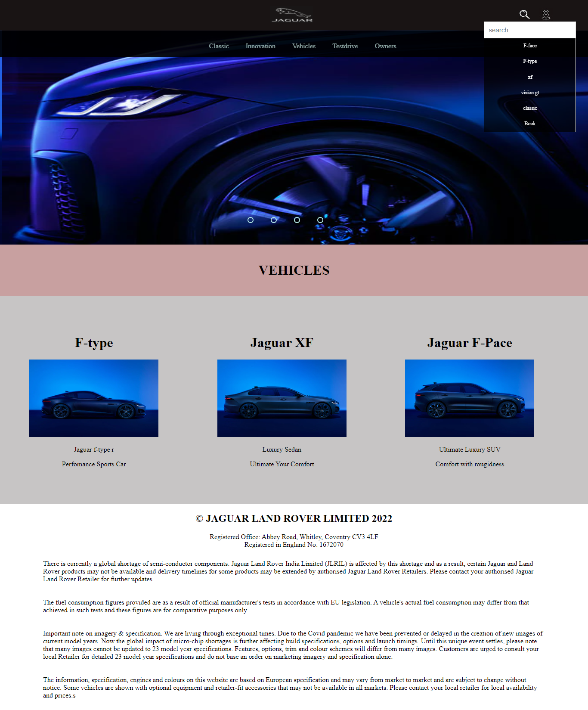

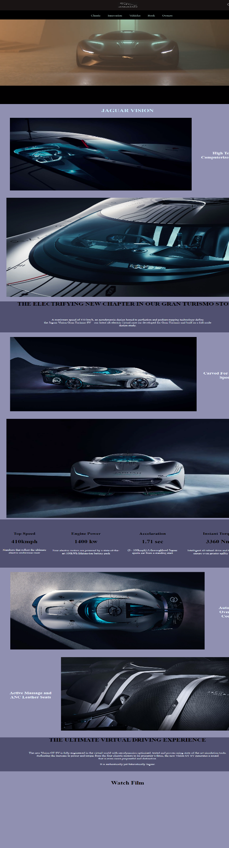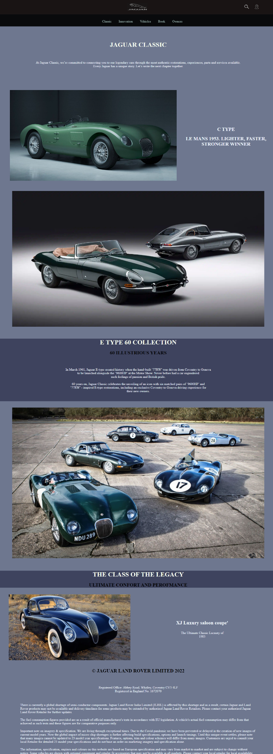

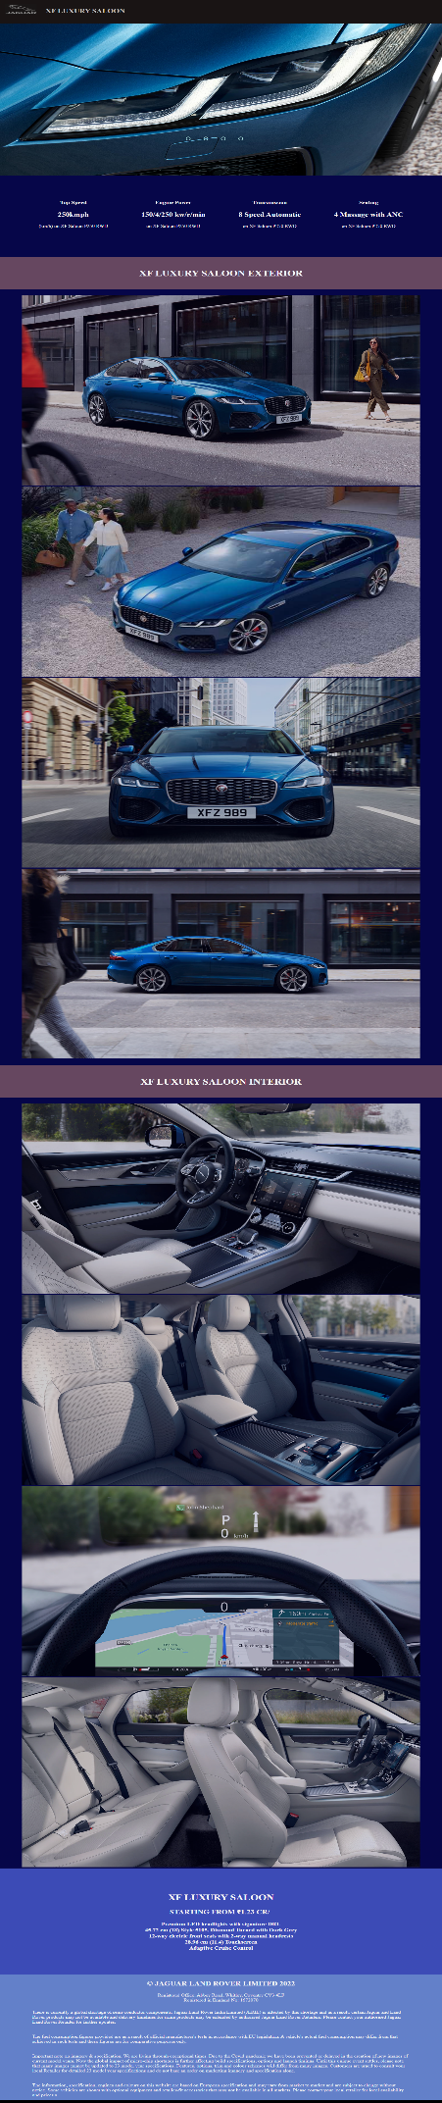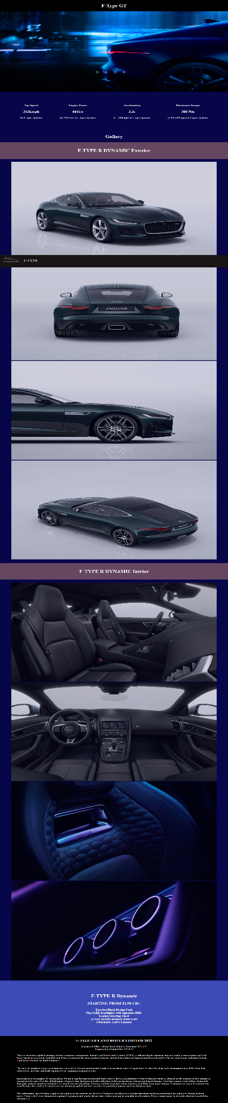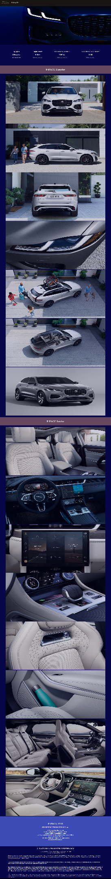

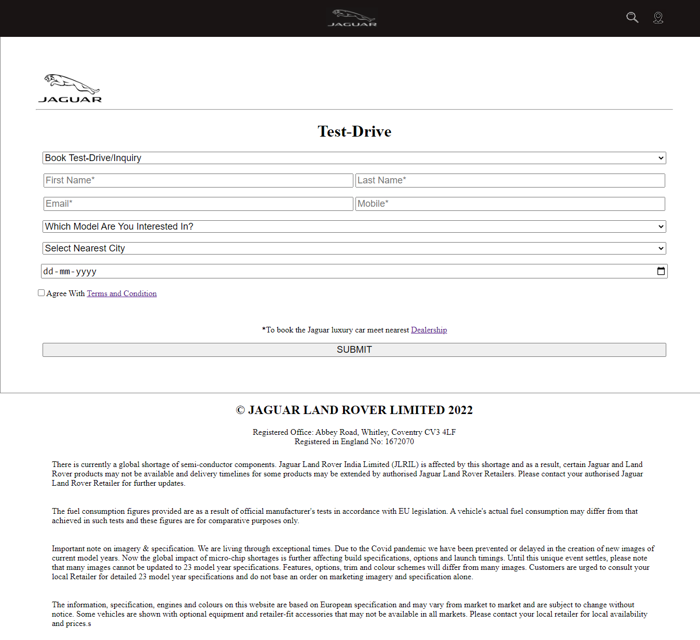

Thank You 😊

Regards SHIVAM RANA

Signature staff In Charge